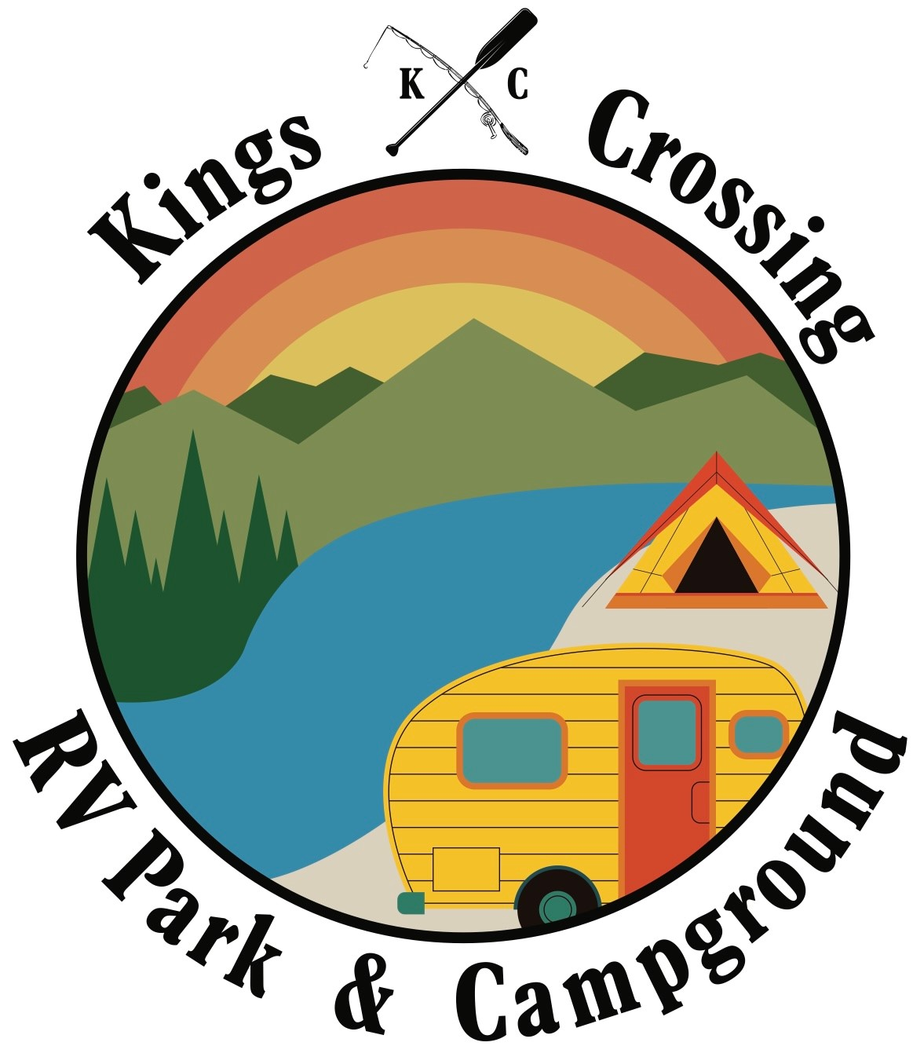 | Volunteer Camp/Park Host Application

- Applicant(s) Name: __________________________________________________________
Address: __________________________________________________________
__________________________________________________________
_____________________ ______________________ _______________________
Phone (including area code) Email address Driver’s License Number
- Number of family members who will be residing at park: (including applicant(s)) _________________________________________________________________________________
- Employed: __________ Retired: __________
- Occupation, if employed: __________________________________________________________
- Outdoor interests or hobbies: (fishing hunting, gardening, birdwatching, etc.): __________________________________________________________________________________________________________________________________________________________________
- Camping equipment to be used by (HOST ONLY)
Camper _____ Motorhome _____ Trailer _____
Size of length of equipment: ___________Make: ____________ Model:________Year:_________
- Please list any additional vehicles/trailers/atvs/boats?__________________________________________
_____________________________________________________________________________________
- Do you have any pets? __________ If yes type and breed______________________________________
- Dates you will be available: ____/____/____ through ____/____/____
- How did you learn about Kings Crossing RV Park & Campground Host Program: __________________________________________________________________________________________________________________________________________________________________

- Have you been a caretaker / host in other parks? If yes, please list parks and approximate dates. ___________________________________________________________________________________________________________________________________________________________________________________________________________________________________________________
- May we contact these parks for reference? _______________________________________________
- What are reasons for volunteering for Camp/Park Host position: ___________________________________________________________________________________________________________________________________________________________________________________________________________________________________________________
- What do you hope to contribute and gain from the Camp/Park Host program? __________________________________________________________________________________________________________________________________________________________________
Comments: __________________________________________________________________________

____________________________________________________________________________________

____________________________________________________________________________________

I authorize the investigation of all matters that Kings Crossing RV Park & Campground may deem relevant to my qualifications for this duty.
_________________________________ _______________________________
Applicant Signature Applicant Signature
___________________________________ _________________________________
Printed Name Printed Name
___________________________________ _________________________________
Date Date
___________________________________ _________________________________
Social Security Number Social Security Number
_______________________________________ _____________________________________
_____________________________________ ______________________________________
Date of Birth Date of Birth

